1. Illustrate the use of background properties in CSS (for image).

Code:

<html>

<head><title>1</title>

<style>

body{

background-image:url("yello.jpeg");

background-color:#ffffff;

background-repeat:repeat-x;

background-size: 50%;

background-position: top;

background-attachment:scroll;

}

</style>

</head>

<body>

<h1 class="image">The background property(image)</h1>

</body>

</html>

Output:

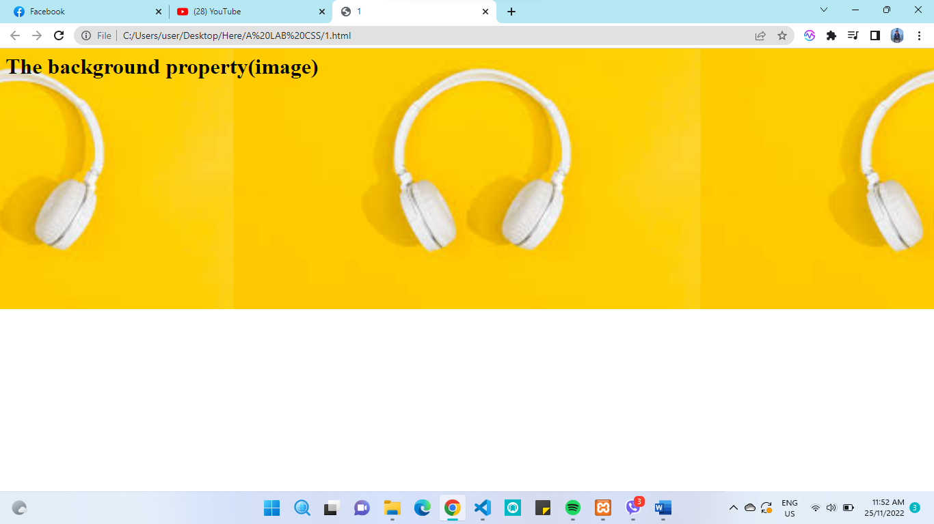

1. Construct a web page with four paragraph and style using CSS.

Code:

<html>

<head><title>2</title>

<style>

p{

font-size:20px;

background-color:white;

font-family: Arial, Helvetica, sans-serif;

}

.a16{

text-align: left;

color: red;

text-decoration:underline black solid;

line-height: 20px;

}

.b16{

text-align:justify;

color:blue;

word-spacing: 5px;

}

.c16{

text-align:center;

color:brown;

letter-spacing: 2px;

}

.d16{

text-align:right;

color:black;

}

</style>

</head>

<body>

<P class="a16">Al contrario del pensamiento popular, el texto de Lorem Ipsum no es simplemente texto aleatorio.

Tiene sus raices en una pieza cl´sica de la literatura del Latin, que data del año 45 antes de Cristo,

haciendo que este adquiera mas de 2000 años de antiguedad.</P>

<P class="b16">This is a css text property demo. This is done using inline and internal css. </p>

<p class="c16">Hay muchas variaciones de los pasajes de Lorem Ipsum disponibles, pero la mayoría sufrió alteraciones en alguna manera,</p>

<p class="d16">Es un hecho establecido hace demasiado tiempo que un lector se distraerá con el contenido del texto de un sitio mientras que mira</p>

</body>

</html>

Output: 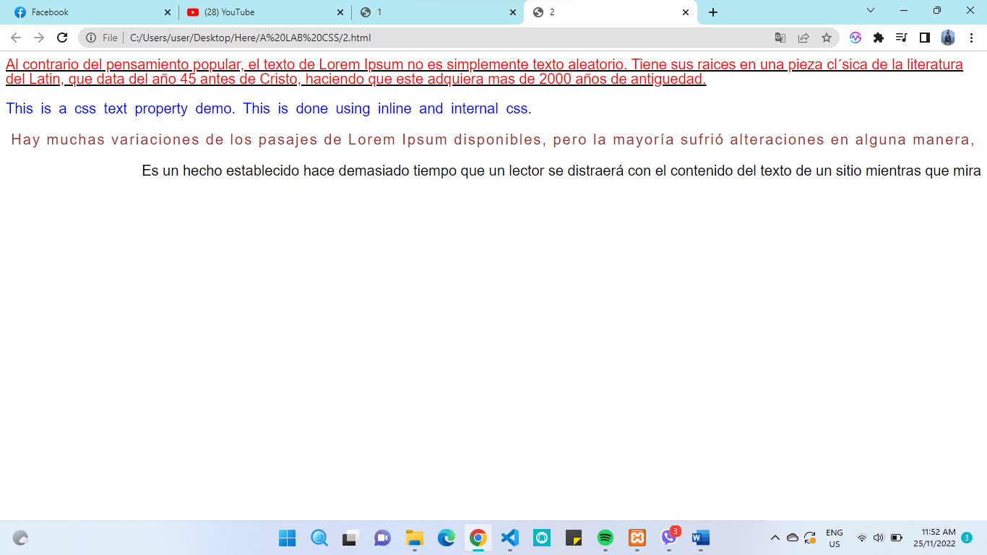

1. Design a web page with six images and style them using external CSS.

Code:

<html>

<head><title>3</title>

<link rel="stylesheet" type="text/css" href="3.css">

</head>

<body>

<img src="yello.jpeg" alt="not found" Class="a16">

<img src="yello.jpeg" class="b16">

<img src="yello.jpeg" class="c16">

<img src="yellow.jpeg" class="d16">

<img src="yellow.jpeg" class="e16">

<img src="yellow.jpeg" class="f16">

</body>

</html>

External stylesheet

.a16{

width:100 px;

margin: 30px;

padding:2px;

border: 4px solid #ddd;

height: 100px;

}

.c16{

width:300 px;

margin: 30px;

padding:2px;

border: 2px solid blue;

height: 300px;

border-radius: 20%;

}.b16{

width:250px;

margin: 30px;

padding:2px;

border: 2px solid green;

height: 200px;

border-radius: 60%;

}

.d16{

width: 300px;

margin: 10px;

padding:2px;

margin-top: 10px;

margin-right: 95px;

}

.e16{

width: 300px;

padding:2px;

margin-top: 10px;

}

.f16{

width: 300px;

margin: 10px;

padding:2px;

margin-top: 10px;

margin-left: 95px;

opacity: 0.7;

}

Output:

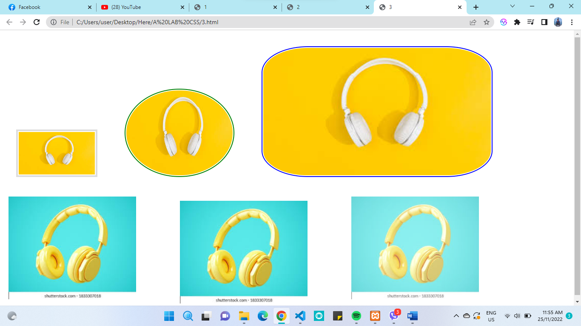

1. Make a nested list using internal CSS.

Code:

<html>

<head><title>4</title>

<style>

ol.a16{

list-style-type: upper-alpha;

list-style-position: inside;

}

ul.b16{

list-style-type: disc;

list-style-position: outside;

}

</style>

</head>

<body>

<h2>Example of nested list using internal css</h2>

<ol class="a16">

<li>Morang

<ul class="b16">

<li>Biratnagar</li>

<li>Belbari</li>

<li>sundarharicha</li>

</ul>

</li>

<li>Sunsari</li>

<li>kathmandu</li>

<li>Birgunj</li>

<li>Dolpa</li>

</ol>

</body>

</html>

Output:

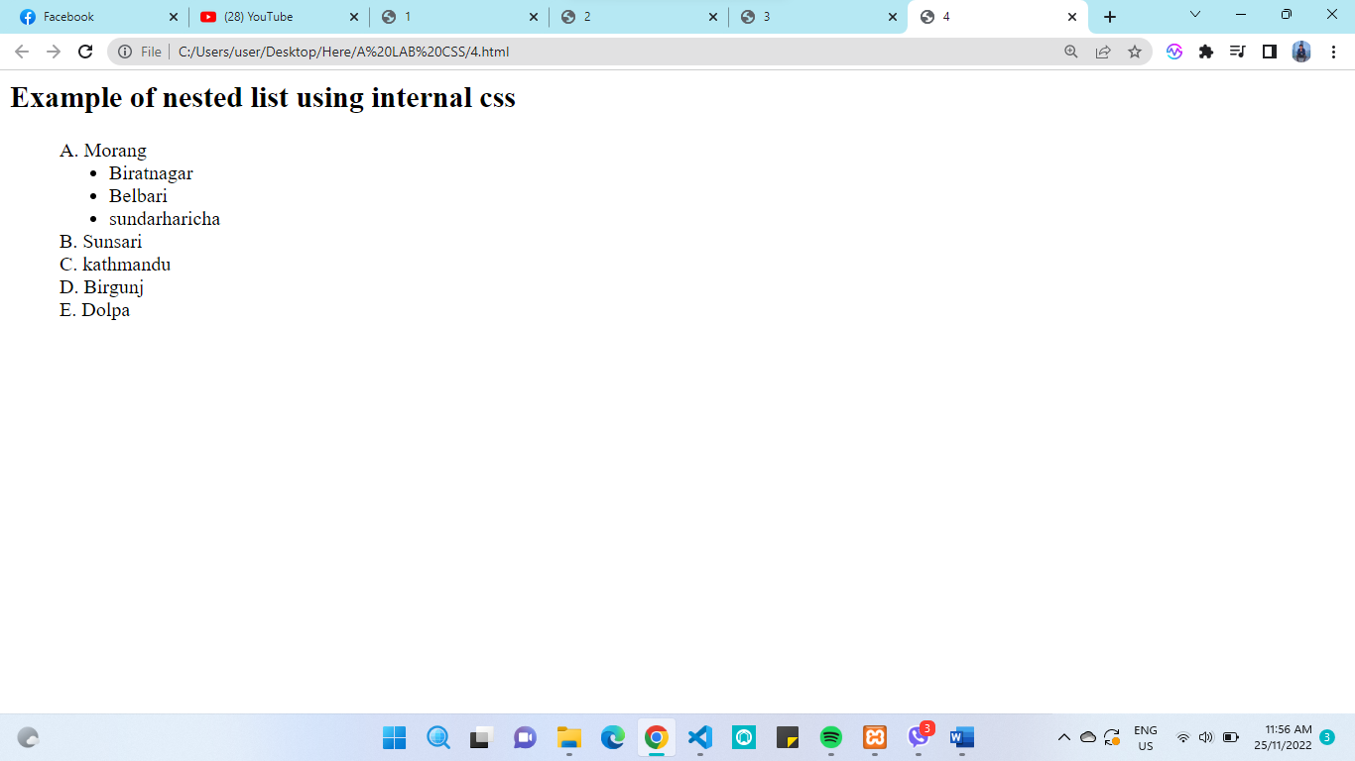

1. Make a web page having 3 rows and 2 columns with all the hyperlinks and style it using CSS.

Code:

<html>

<head>

<title>5</title>

<style>

.row1 , .row2, .row3 {

height: 30vh;

margin: 10px auto;

}

.box16{

border: 2px solid black;

box-sizing: border-box;

width: 45%;

height: 100%;

display: inline-block;

}

#one16{

background-color: red;

}

#two16{

background-color: green;

}

#three16{

background-color: blue;

}

#four16{

background-color: peru;

}

#five16{

background-color: purple;

}

#six16{

background-color: yellow;

}

</style>

</head>

<body>

<div class="row1">

<a href="http://www.google.com">

<div class="box16" id="one16">

</div>

</a>

<a href="http://www.google.com">

<div class="box16" id="two16">

</div>

</a>

</div>

<div class="row2">

<a href="http://www.google.com">

<div class="box16" id="three16" >

</div>

</a>

<a href="http://www.google.com">

<div class="box16" id="four16">

</div>

</a>

</div>

<div class="row3">

<div class="box16" id="five16">

</div>

<div class="box16" id="six16">

</div>

</div>

</body>

</html>

Output:

1. Design an html form to demonstrate the 10 different types of controls generated using INPUT tag. Style the form as:

* Set the background color of textbox yellow when it is focused.
* Change the text color blue to textbox.
* Increase the height of combo options when it is checked.
* Set the border color red if the input is invalid in textbox and textarea.
* Set green border to valid input.
* Design the form using fieldset.

Code:

<html>

<head>

<title>6</title>

<style>

input:focus{

background-color: yellow;

}

input{

color: blue;

}

input:invalid{

border:2px solid red;

}

textarea:invalid{

border:2px solid red;

}

textarea,input:valid{

border:2px solid green;

}

option:checked {

height: 500px;

width: 100px;

line-height: 100px;

size: 50%;

}

</style>

</head>

<body>

<form method="post" action="#">

<fieldset style="width:50%">

Name:<input type="text" class="name16"><br>

password:<input type="password" class="pass16"><br>

Email:

<input type="email" name="email" class="email16"><br>

Phone No:

<input type="number" name="number" class="phno16"><br>

Date:

<input type="date" name="date" class="date16"><br>

Gender:

<input type="radio" name="gender" value="male" class="male16">male

<input type="radio" name="gender" value="female" class="female16">female

<br>

Vehicles:<br>

<input type="checkbox" id="vehicle1" name="vehicle1" value="Bike">

<label for="vehicle1"> I have a bike</label><br>

<input type="checkbox" id="vehicle2" name="vehicle2" value="Car">

<label for="vehicle2"> I have a car</label><br>

<input type="checkbox" id="vehicle3" name="vehicle3" value="Boat">

<label for="vehicle3"> I have a boat</label><br>

Location:

<select name="location" class="select16">

<option value="">please select</option>

<option value="pokhara">pokhara</option>

<option value="ktm" >kathmandu</option>

<option value="brt">biratnagar</option>

<option value="lx">laxmimarga</option>

</select>

<br>

Comments:

.<textarea name="textarea" class="textarea16">Write down your comments </textarea><br>

select file:

<input type="button" name="ok" value="ok" >

<input type="reset" name="Reset" value="clear">

</fieldset>

</form>

</body>

</html>

Output:

1. Design the given table and style as:

|  |  |
| --- | --- |
| Class A | Class B |
| Class C | Class D |

* Set the border of any style and color.
* Set width of all Classes 600 pixel and height 550 pixel.
* Set different background color for all classes.
* Every text color should be different.
* Display Class C and Class D in uppercase and remaining in lower case.

Code:

<html lang="en">

<head>

<meta charset="UTF-8">

<meta http-equiv="X-UA-Compatible" content="IE=edge">

<meta name="viewport" content="width=device-width, initial-scale=1.0">

<title>Document</title>

<style>

div{

height: 600px;

width: 550px;

display: inline-block;

border: 1px solid yellow;

}

p{

text-align: center;

}

.one{

background-color:red;

}

.two{

background-color:purple;

color: white;

}

.three{

background-color:green;

color: yellow;

}

.four{

background-color:blue;

color: orange;

}

.one p, .two p{

text-transform: lowercase;

}

.four p, .three p{

text-transform: uppercase;

}

</style>

</head>

<body>

<div class="one"><p>class a</p></div>

<div class="two"><p>class b</p></div>

<div class="three"><p>class c</p></div>

<div class="four"><p>class d</p></div>

</body>

</html>

Output:

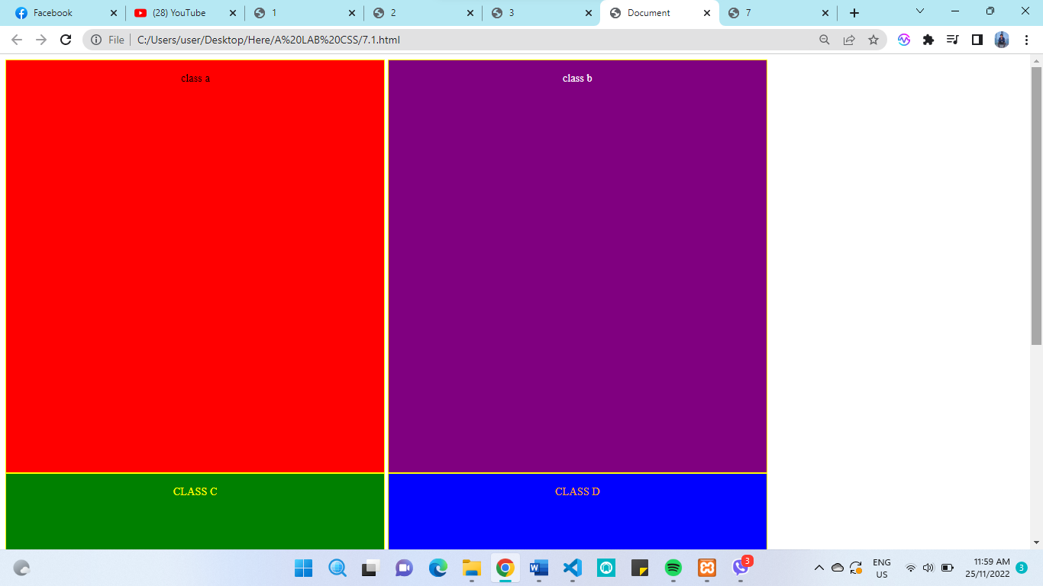

1. Design a horizontal menu of any five options and style as:

* Set border for all links.
* Set different background color and text color.
* Change the font color and increase the font size when mouse over it.
* Remove the underline from link.
* Change all the default behaviour of links.

Code:

<html>

<head>

<title>8</title>

<style>

.box16{

border: 2px solid red;

box-sizing: border-box;

width: 16%;

height: 15%;

display: inline-block;

}

a{

text-decoration: none;

text-align: center;

color: brown;

transition: width;

}

a:hover

{

color:black;

}

</style>

</head>

<body>

<div class="row1">

<a href="http://www.google.com">

<div class="box16" id="one16" <p>facebook</p>

</div>

</a>

<a href="http://www.google.com">

<div class="box16" id="two16"<p>google</p>

</div>

</a>

</a>

<a href="http://www.google.com">

<div class="box16" id="two16"<p>instagram</p>

</div>

</a>

</a>

<a href="http://www.google.com">

<div class="box16" id="two16"<p>twitter</p>

</div>

</a>

</a>

<a href="http://www.google.com">

<div class="box16" id="two16"<p>youtube</p>

</div>

</a>

</div>

</body>

</html>

Output:

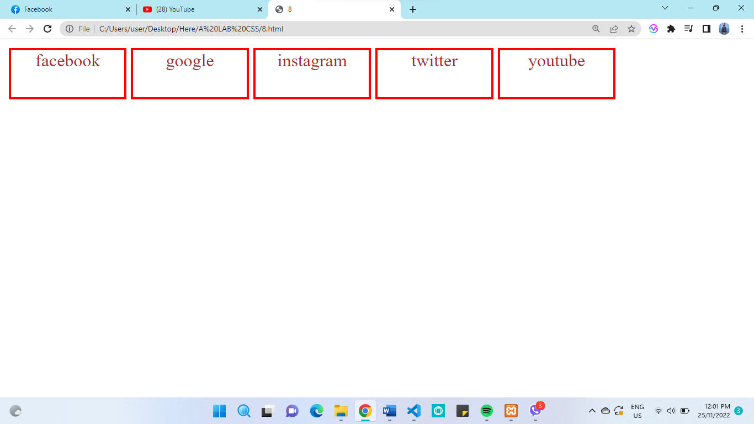

1. Develop a web page with a paragraph and add some contents before the paragraph with red color and yellow background using CSS.

Code:

<html>

<head>

<title>9</title>

<style>

p::before

{

content: "This is lorem ipsum";

color: red;

background-color:yellow;

}

</style>

</head>

<body>

<p> Lorem ipsum, or lipsum as it is sometimes known, is dummy text used in laying out print, graphic

or web designs. The passage is attributed to an unknown typesetter in the 15th century who is

thought to have scrambled parts of Cicero's De Finibus Bonorum et Malorum for use in a type specimen

book. It usually begins with:

</p>

</body>

</html>

Output:

1. Illustrate the concept of pseudo elements with example. (::after, ::first-letter, ::selection, ::first-line)

Code:

<html>

<head>

<title>10</title>

<style>

p::after{

content: " this is after";

color:blue;

}

::selection{

background-color: red;

}

p::first-line{

color:brown;

}

p::first-letter{

background-color: aqua;

}

</style>

</head>

<body>

<p>This is the example of some pseudo elements like after,selection,firstline etc

Lorem ipsum dolor sit amet consectetur, adipisicing elit. Quos, soluta aspernatur? Ullam,

distinctio laboriosam rem ad quasi minus magnam quam ipsam sint qui sequi voluptatibus ipsum

et explicabo repellat ipsa.

</p>

</body>

</html>

Output:

1. Design following list using html and CSS

* Mouse
* Keyboard
* Monitor
* Printer
* Touchpad

Code:

<html>

<head>

<title>11</title>

<style>

ul {

list-style-type: none;

}

ul li::before {

content: '✓ ';

}

</style>

</head>

<body>

<ul>

<li>Mouse</li>

<li>Keyboard</li>

<li>Monitor</li>

<li>Printer</li>

<li>Touchpad</li>

</ul>

</body>

</html>

Output: 